|  |  |
| --- | --- |
| COLOUR_LOGO Aug 2010 | **Year 12 *ATAR* Physics Unit 4** **2017**  ***TEST 6 Charged Particles in E and B Fields 4.0%***  **NAME: ………………………………………………….**  Data: See Data Sheet  Approx. marks shown.  ***(56 marks)*** |

When calculating numerical answers, show your working or reasoning clearly. Give final answers to **three** significant figures and include appropriate units where applicable.

When estimating numerical answers, show your working or reasoning clearly. Give final answers to a maximum of **two** significant figures and include appropriate units where applicable.

1. Multiple Choice [2]
2. Which diagram represents the electric field in the vicinity of a positive electric charge of magnitude Q?

|  |  |
| --- | --- |
|  |  |

1. A positively charged particle is projected into a region of uniform magnetic field B. Which diagram represents the motion of the particle in the magnetic field?

|  |
| --- |
| B  B  **A** **B** |
| B  B  **C** **D** |

1. Figure 1 shows a piece of cotton and a plastic ruler before they are rubber together.

Figure 2 shows the piece of cotton and the plastic ruler after they are rubber together.

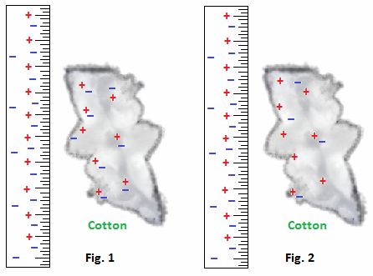

1. Explain briefly why the ruler becomes charged. [2]

...........................................................................................................................................

...........................................................................................................................................

...........................................................................................................................................

...........................................................................................................................................

...........................................................................................................................................

1. The plastic ruler from Figure 2 repels a rubber rod, so both the ruler and the rod have *positive negative neutral* charges. Circle the correct answer/s.

Explain briefly. [1]

...........................................................................................................................................

1. The plastic ruler from Figure 2 attracts an acetate rod, so both the ruler and the rod have *positive negative neutral* charges. Circle the correct answer/s.

Explain briefly. [3]

...........................................................................................................................................

...........................................................................................................................................

...........................................................................................................................................

...........................................................................................................................................

...........................................................................................................................................

...........................................................................................................................................

1. A student draws the following diagram to explain electrostatic induction. Comment on the accuracy of the diagram after the rod has been presented. [2]

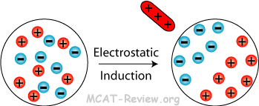

...........................................................................................................................................

...........................................................................................................................................

...........................................................................................................................................

...........................................................................................................................................

|  |  |
| --- | --- |
| 1. Consider the following diagram of an electric field around 2 point charges. The magnitude of the charge on A is Q. 2. State the signs of the charge on A and B. [2]   ............................................................................  ............................................................................   1. State the magnitude of the charge on B. [1]   ............................................................................ | _Pic1  A  B |

|  |  |
| --- | --- |
| 1. The diagram shows a pair of oppositely charged plates.   Explain the electric field shape and distribution in the diagram. [3]  .....................................................................................  .....................................................................................  .....................................................................................  .....................................................................................  ..................................................................................... | http://dev.cnx.org/resources/059dc9855270722ae19416751361fd48bac9c05f/CNX_APPhysics_19_M2_NonParPlat.jpg  **+**  **–** |

...........................................................................................................................................

...........................................................................................................................................

...........................................................................................................................................

|  |  |
| --- | --- |
| 1. Faraday bags are a type of Faraday cage made of flexible metallic fabric. They are typically used to block remote wiping or alteration of wireless devices recovered in criminal investigations, but may also be used by the general public to protect against data theft.   Use a diagram to explain the operation of the Faraday bag. [4] | https://upload.wikimedia.org/wikipedia/commons/9/9a/MissionDarkness_FaradayBag_phone.jpg |

http://tedkinsman.photoshelter.com/img/pixel.gifhttp://tedkinsman.photoshelter.com/img/pixel.gif

...........................................................................................................................................

...........................................................................................................................................

...........................................................................................................................................

...........................................................................................................................................

...........................................................................................................................................

...........................................................................................................................................

...........................................................................................................................................

...........................................................................................................................................

...........................................................................................................................................

|  |  |
| --- | --- |
| 1. Two large parallel plates X and Z are placed 5.0 mm apart and connected as shown to the terminals of a 200 volt d.c. supply.   A small oil drop at P carries three excess electrons.  What is the magnitude and direction of the electrostatic force acting on the oil drop due to the electric field between the plates? [5]  ............................................................................  ............................................................................  ............................................................................ |  |

...........................................................................................................................................

...........................................................................................................................................

...........................................................................................................................................

...........................................................................................................................................

1. When two small oppositely charged spheres, considered as point charges, are placed in contact and separated to 1.06 m apart, the force each exerts on the other is 12.0 N.
2. What is the charge on each sphere after contact? [3]

...........................................................................................................................................

...........................................................................................................................................

...........................................................................................................................................

...........................................................................................................................................

...........................................................................................................................................

...........................................................................................................................................

...........................................................................................................................................

1. Before making contact one of the two small oppositely charged spheres has a charge of 50.0 μC. What is the original charge on the other sphere? Show your working clearly. [3]

...........................................................................................................................................

...........................................................................................................................................

...........................................................................................................................................

...........................................................................................................................................

...........................................................................................................................................

...........................................................................................................................................

...........................................................................................................................................

1. An alpha particle of mass 6.68 x 10–27 kg travelling with an initial velocity equal to

2.00 x 107 m s–1 enters a region of a uniform electric field midway between the parallel plates of length **ℓ** shown below. The alpha particle is deflected so that it just passes out between the plates (ie at either point **X** or point **Y**)

ℓ

X

Y

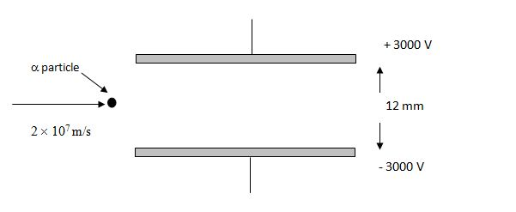

1. On the above diagram draw the trajectory of the alpha particle. [2]
2. Determine the magnitude of the electric field strength between the parallel plates.

[2]

...........................................................................................................................................

...........................................................................................................................................

...........................................................................................................................................

1. Find the acceleration of the alpha particle. [3]

...........................................................................................................................................

...........................................................................................................................................

...........................................................................................................................................

...........................................................................................................................................

1. Determine the time it takes for alpha particle to just pass out between the plates. [2]

...........................................................................................................................................

...........................................................................................................................................

...........................................................................................................................................

...........................................................................................................................................

1. Determine the length **ℓ** ofthe parallel plates. [2]

...........................................................................................................................................

...........................................................................................................................................

...........................................................................................................................................

1. Find the direction of the force, if any, on each charged particle for each diagram shown below, where ***v*** is the velocity of the charge and **B** is the direction of the magnetic field. ( means the vector points inward.  means it points outward, toward you.) [4]

|  |  |  |  |
| --- | --- | --- | --- |
| Particle is Mg 2+ ion  _Pic2  .................................... | Particle is F – ion  _Pic1  ..................................... | Particle is proton  _Pic4  ...................................... | Particle is electron  _Pic3  ...................................... |

1. The path of a charged particle in a uniform magnetic field is shown below in Figure 1. It travels at 2.0 x 107 m s–1 in a plane perpendicular to a uniform 0.010 T magnetic field.

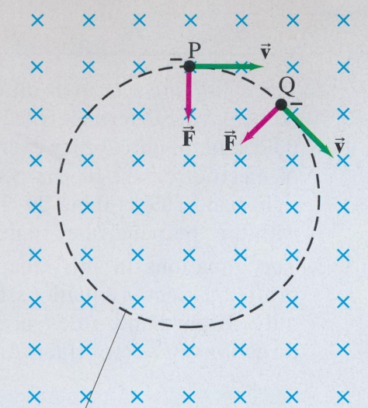

**Figure 1**

1. State whether the particle is *positive* or *negative.* Circle the correct answer. [1]
2. Given that the circle shown is full size estimate the charge-to-mass ratio of the particle.

[5]

...........................................................................................................................................

...........................................................................................................................................

...........................................................................................................................................

...........................................................................................................................................

...........................................................................................................................................

...........................................................................................................................................

...........................................................................................................................................

...........................................................................................................................................

1. Assuming that the beam of particles in (a) is positively charged and passes undeflected at 2.0 x 107 m s–1 when passing through perpendicular electric and magnetic fields

.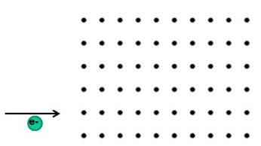

**Figure 2**

1. If the magnitude of the electric field is 8.8 x 103 V m–1 determine the magnitude of magnetic field. Show your working clearly, including the relevant formulae from the Data Sheet. [3]

...........................................................................................................................................

...........................................................................................................................................

...........................................................................................................................................

...........................................................................................................................................

...........................................................................................................................................

1. On Figure 2 show the direction of the electric field. [1]

End of Test